ansible challenges
Create ci pipeline that will deploy and configure these VMs using terraform and ansible according following requirements
- Deploy 2 virtual machines using terraform.
  - first vm on Amazon linux, hostname: c8.local
  - second vm on ubuntu 21.04, hostname: u21.local
- As a result of terraform execution, dynamically create inventory for ansible
  - c8.local should be in the frontend group
  - u21.local should be in the backend group
- Create ansible playbook for c8.local and u21.local
- for linux OS playbook should apply the following changes
  - selinux: disable
  - firewalld: disable
- for frontend playbook group should install and configure nginx
  - nginx configuration should do proxying from port 80 on port 19999 to the
- check the Jenkins main server available tools
- terraform
- ansible
- java
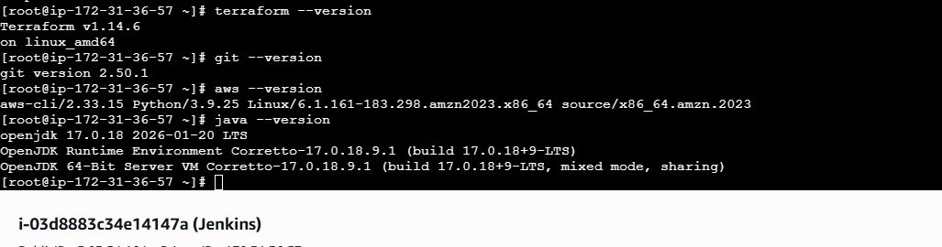
- Install the pluggin
- Aws credentials
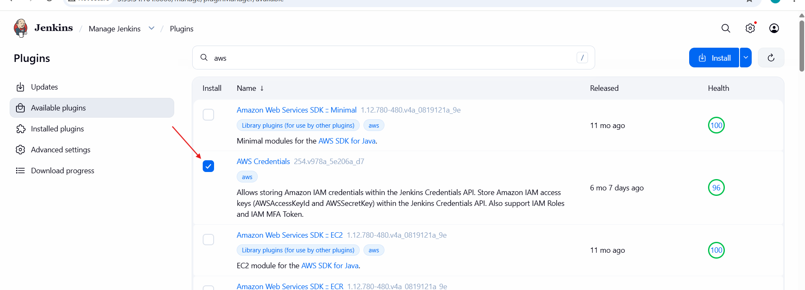
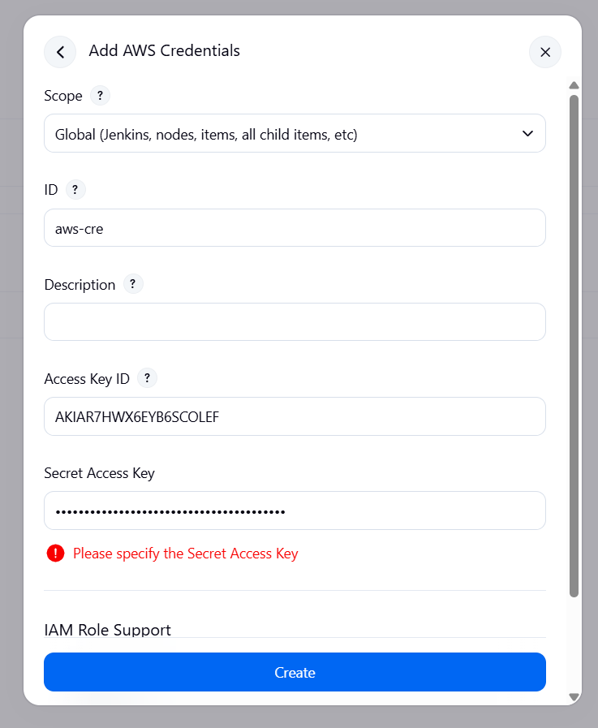
- Add ur pem.key in the jenkins
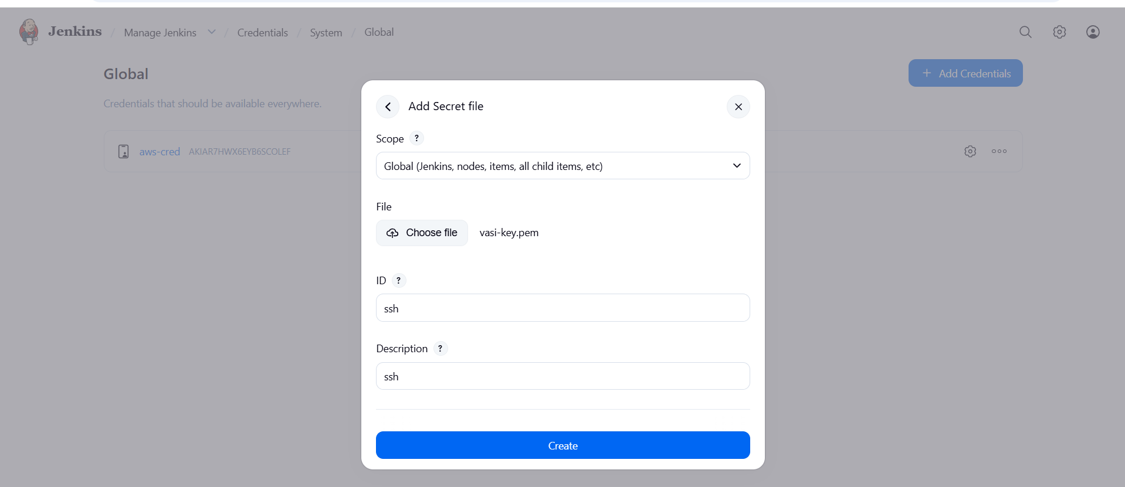
- Successfully key is added
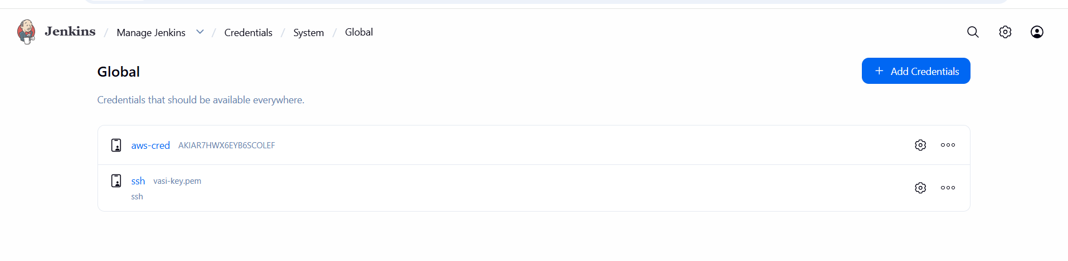
Configure the jenkins
Add the repo in the configueration
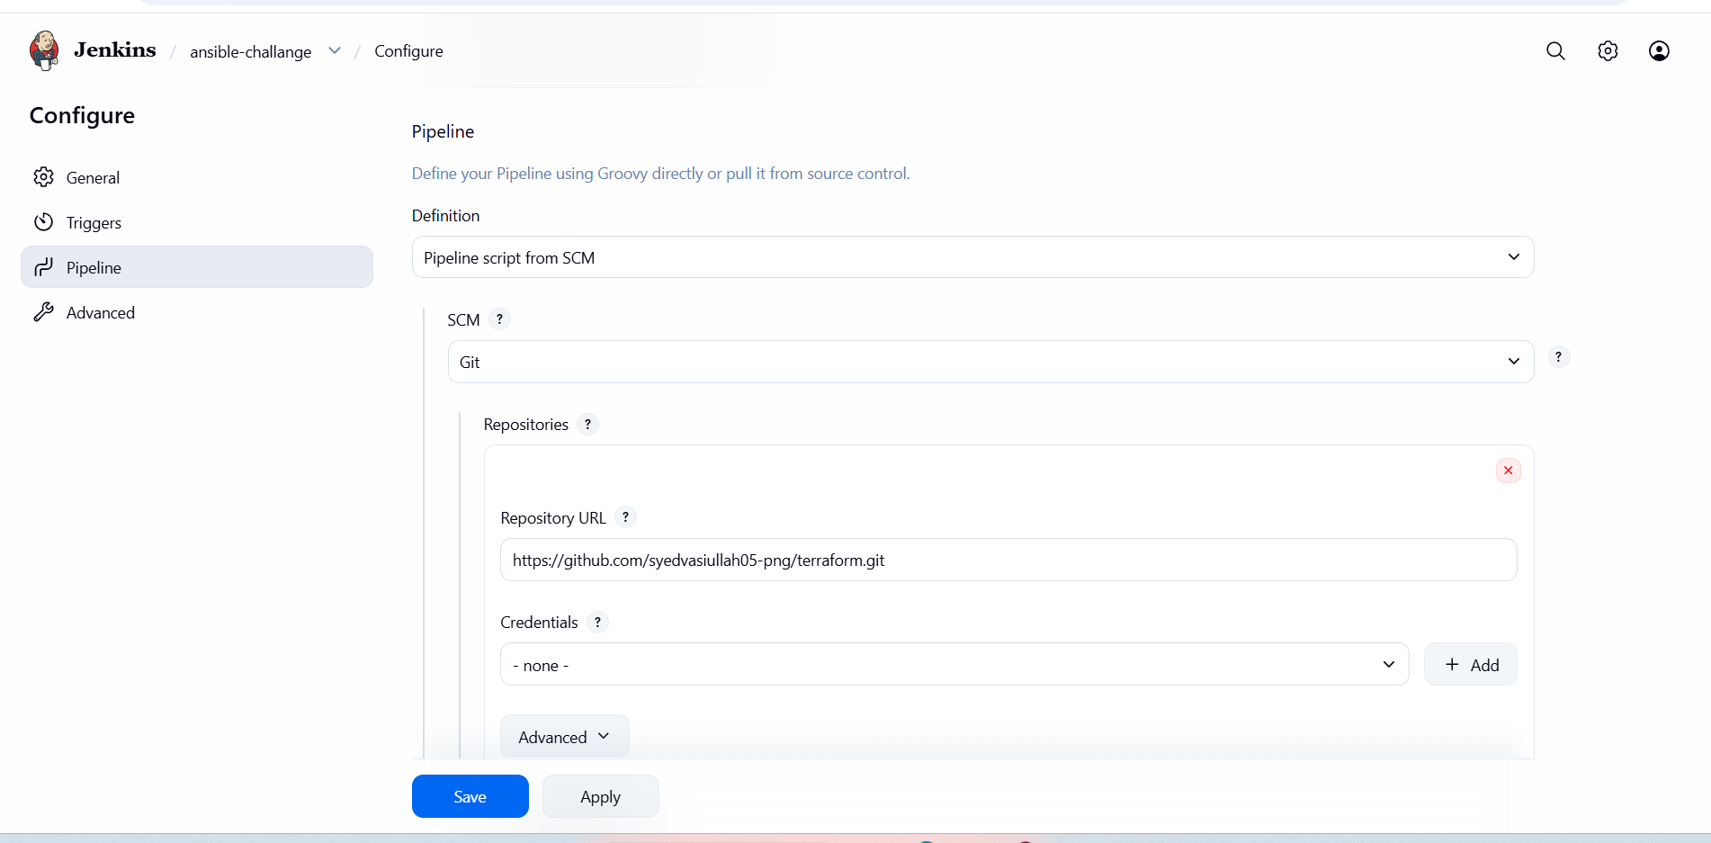
- GitHub repository (public)
- Security Groups allowing:
  - SSH (22)
  - HTTP (80)
  - Netdata (19999)

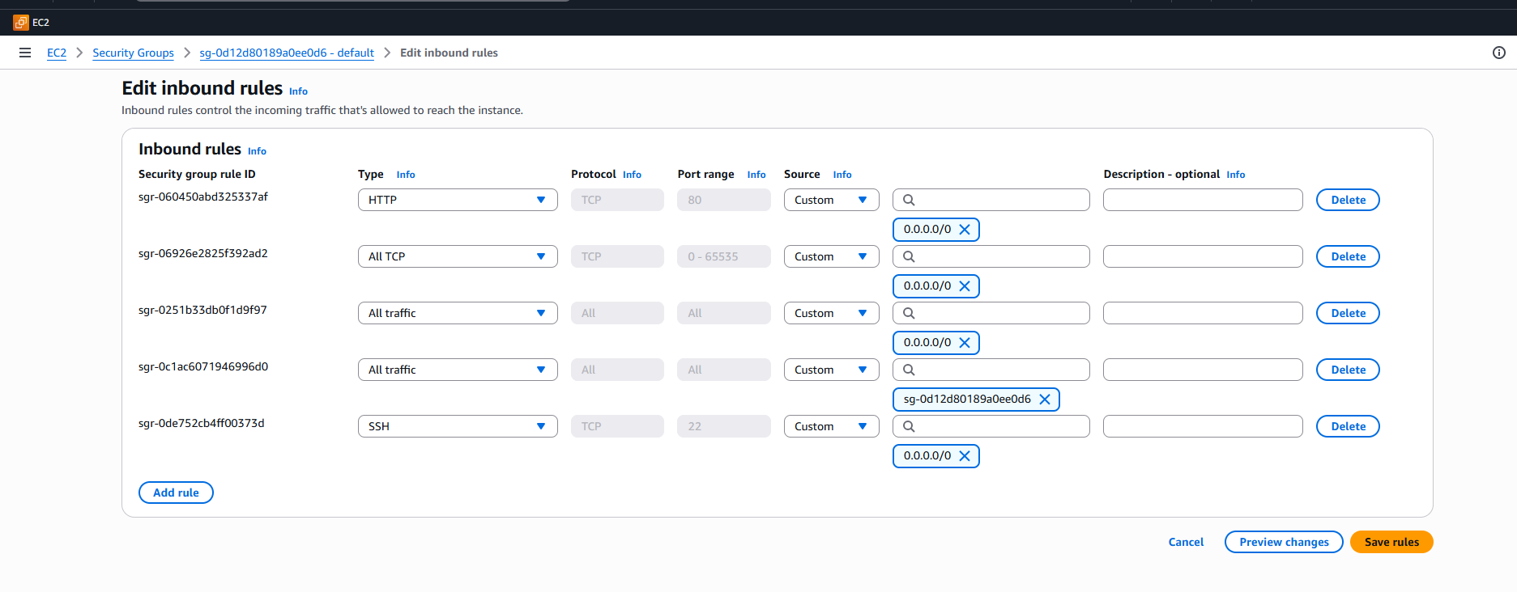
GitHub Repository Structure
ansible-challenge
- ansible/
linux.yml
backend.yml
frontend.yml
- terraform/
ec2..tf
inventory.tf
- Jenkinsfile
README.md
Step-by-Step Implementation:
Step 1: Create GitHub Repository
- Repository name: ansible-challenge
- Visibility: Public
- Added README
- Pushed Terraform, Ansible, and Jenkinsfile

Step 2: Terraform – Infrastructure Provisioning
ec2.tf:
provider "aws" {
region = "us-east-1"
}
resource "aws_instance" "frontend" {
ami = "ami-0f3caa1cf4417e51b"
instance_type = "t3.micro"
key_name = "vasi-key"
tags = {
Name = "c8.local"
}
}

resource "aws_instance" "backend" {
ami = "ami-0b6c6ebed2801a5cb"
instance_type = "t3.micro"
key_name = "vasi-key"
tags = {
Name = "u21.local"
}
}

Step 3: Terraform – Dynamic Ansible Inventory
inventory.tf:
resource "local_file" "ansible_inventory" {
filename = "${path.module}/../ansible/inventory.ini"
content = <<EOF
[frontend]
c8.local ansible_host=${aws_instance.frontend.public_ip} ansible_user=ec2-user

[backend]
u21.local ansible_host=${aws_instance.backend.public_ip} ansible_user=ubuntu

EOF
}
Step 4: Ansible – Common Configuration
linux.yml
---
- name: Common Linux Configuration
hosts: all
become: yes

tasks:

- name: Disable SELinux immediately (RHEL-based only)
ansible.posix.selinux:
state: disabled
when: ansible_os_family == "RedHat"

- name: Disable SELinux permanently (RHEL-based only)
lineinfile:
path: /etc/selinux/config
regexp: '^SELINUX='
line: 'SELINUX=disabled'
when: ansible_os_family == "RedHat"

- name: Stop firewalld (if exists)
service:
name: firewalld
state: stopped
ignore_errors: yes

- name: Disable firewalld (if exists)
service:
name: firewalld
enabled: no
ignore_errors: yes
Step 5: Ansible – Backend (Netdata)
backend.yml :
---
- name: Install and Configure Netdata Backend
hosts: backend
become: yes

tasks:

- name: Install required packages (Ubuntu/Debian)
apt:
update_cache: yes
name:
- curl
state: present
when: ansible_os_family == "Debian"

- name: Install required packages (RHEL/Amazon)
yum:
name:
- curl
state: present
when: ansible_os_family == "RedHat"

# ✅ FIXED SECTION (No more bash process substitution)

- name: Download Netdata install script
get_url:
url: https://my-netdata.io/kickstart.sh
dest: /tmp/netdata-kickstart.sh
mode: '0755'
when: not ansible_facts.services['netdata.service'] is defined
ignore_errors: yes

- name: Install Netdata
command: bash /tmp/netdata-kickstart.sh --dont-wait
args:
creates: /usr/sbin/netdata

- name: Ensure Netdata binds to port 19999
lineinfile:
path: /etc/netdata/netdata.conf
regexp: '^\s*bind to ='
line: ' bind to = 0.0.0.0:19999'
notify: restart netdata
ignore_errors: yes

- name: Enable and start Netdata
service:
name: netdata
state: started
enabled: yes

handlers:
- name: restart netdata
service:
name: netdata
state: restarted

Step 6: Ansible – Frontend (Nginx Reverse Proxy)
frontend.yml
---
- name: Configure Frontend with Nginx Reverse Proxy
hosts: frontend
become: yes

vars:
backend_server: "{{ groups['backend'][0] }}"

tasks:

- name: Install nginx (Amazon Linux / RHEL)
yum:
name: nginx
state: present
when: ansible_os_family == "RedHat"

- name: Install nginx (Ubuntu/Debian)
apt:
name: nginx
state: present
update_cache: yes
when: ansible_os_family == "Debian"

- name: Configure nginx reverse proxy
copy:
dest: /etc/nginx/conf.d/netdata.conf
content: |
server {
listen 80;
server_name _;

location / {
proxy_pass http://{{ hostvars[backend_server].ansible_host }}:19999;
proxy_http_version 1.1;
proxy_set_header Host $host;
proxy_set_header X-Real-IP $remote_addr;
proxy_set_header X-Forwarded-For $proxy_add_x_forwarded_for;
proxy_set_header X-Forwarded-Proto $scheme;
}
}
notify: restart nginx

- name: Remove default nginx config (if exists)
file:
path: /etc/nginx/conf.d/default.conf
state: absent
ignore_errors: yes

- name: Start and enable nginx
service:
name: nginx
state: started
enabled: yes

handlers:
- name: restart nginx
service:
name: nginx
state: restarted

Step 7: Jenkins Pipeline Setup
Jenkinsfile

pipeline {

agent any

environment {

AWS_DEFAULT_REGION = "us-east-1"
ANSIBLE_HOST_KEY_CHECKING = "False"

}

stages {

stage('Checkout Code') {

steps {

git branch: 'main',
url: 'https://github.com/syedvasiullah05-png/terraform.git'

}

}

stage('Terraform Init & Apply') {

steps {

withCredentials([[
$class: 'AmazonWebServicesCredentialsBinding',
credentialsId: 'aws-cred'
]]) {

sh '''
cd terraform
terraform --version
terraform init
terraform apply -auto-approve
'''

}

}

}

stage('Run Ansible Playbooks') {

steps {

sshagent(credentials: ['ssh']) {

sh '''
cd ansible
ansible --version
ansible-playbook -i inventory.ini linux.yml
ansible-playbook -i inventory.ini backend.yml
ansible-playbook -i inventory.ini frontend.yml
'''

}

}

}

}

post {

success {

echo "Deployment completed successfully"

}

failure {

echo "Deployment failed"

}

}

}

Validation Steps
1. Jenkins
- Pipeline status: SUCCESS
- Terraform + Ansible stages completed
- No unreachable hosts

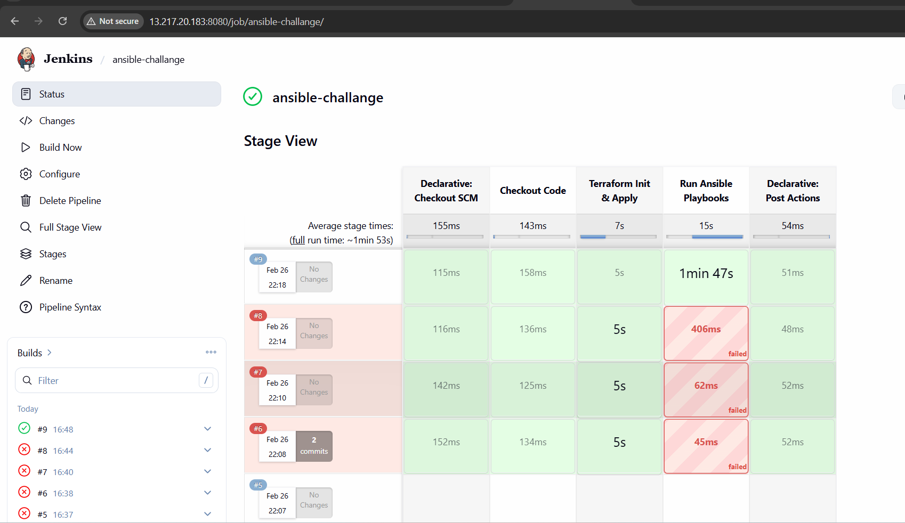
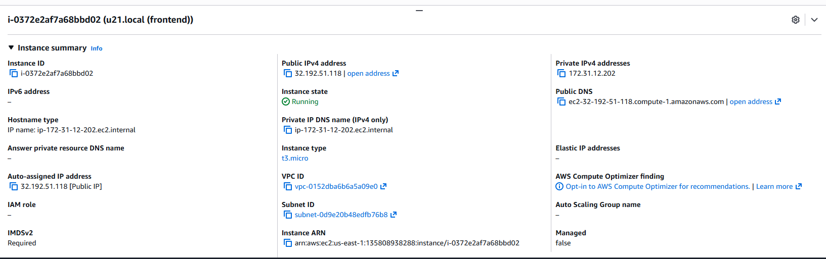
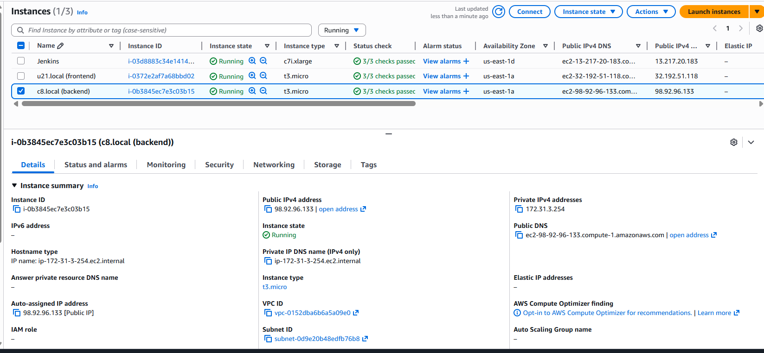
2. Backend (Ubuntu)
sudo systemctl status netdata
sudo ss -tulpn | grep 19999
- Netdata running on 0.0.0.0:19999
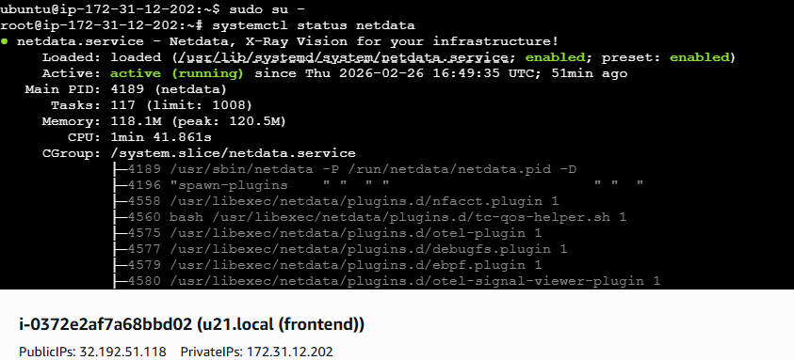
3. Frontend (Amazon Linux)
sudo systemctl status nginx
sudo ss -tulpn | grep 80
Nginx running and listening on port 80
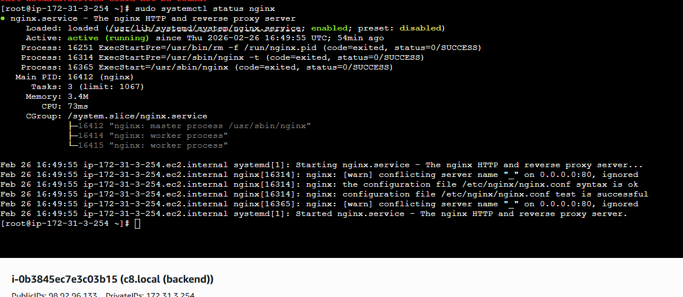
4. Browser Validation
- Direct Netdata:
http://backend_public_ip:19999
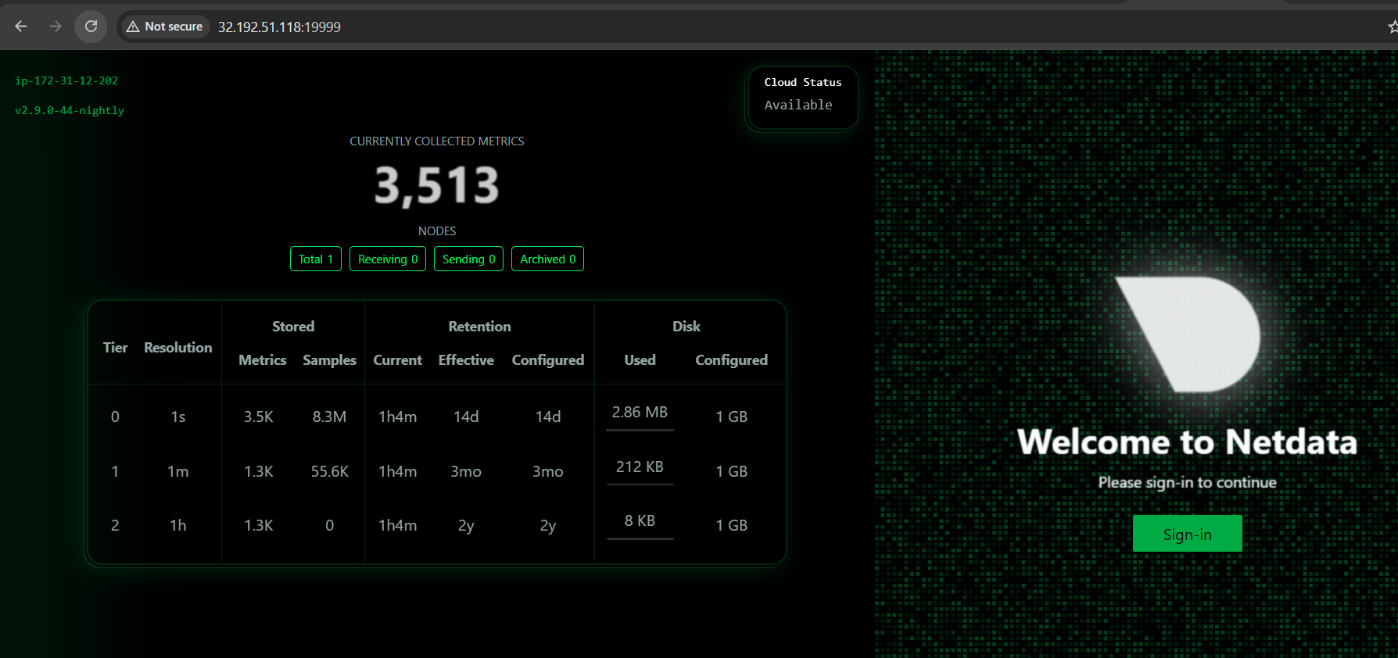
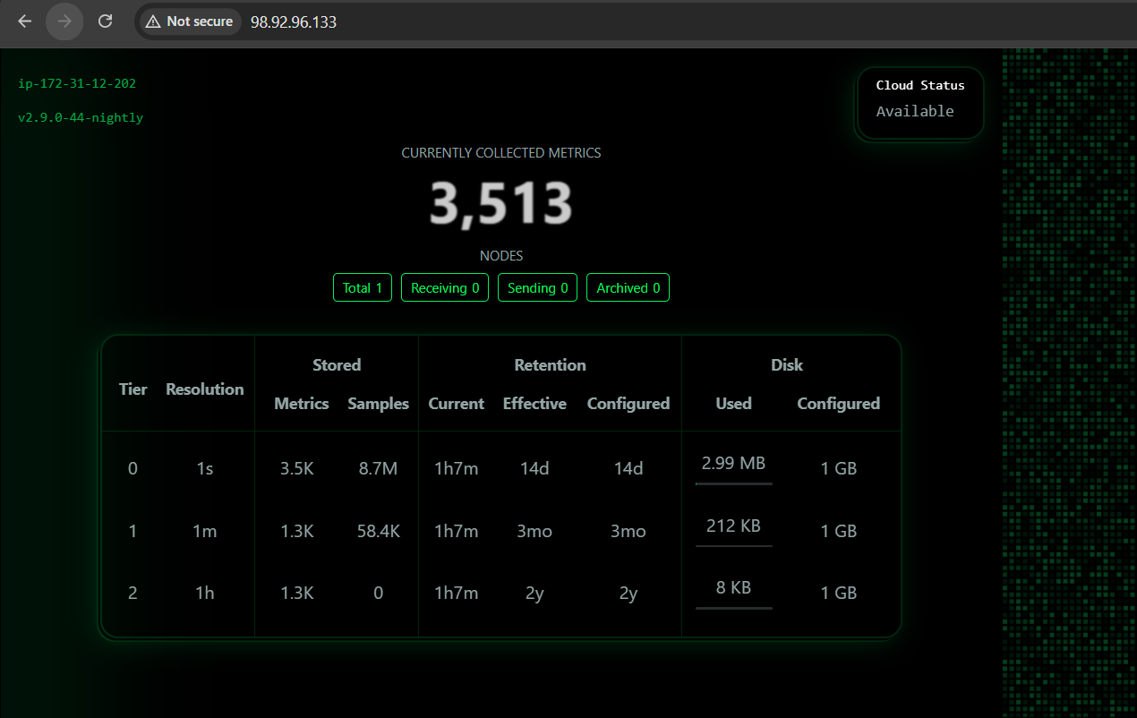
- Netdata dashboard loads successfully in both cases

